Campus wayfinding app – Technical documentation

Technical documentation for Node.js, npm-install with AngularJS, Sourcetree and VS code (Visual Studio Code).

# Setting up a dev environment on Windows

Step 1, Download and install Source Tree app (https://www.sourcetreeapp.com/), once installed login with your Atlassian (bitbucket.org /sourcetreeapp.com) account.

Provided that you have been given access to the repository, you can now make a Pull request for the ‘campus-wayfinding-app’ repo.

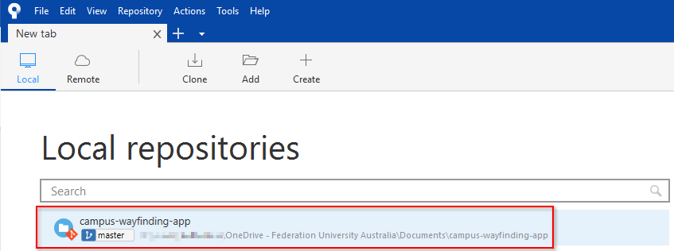

Step 2, Once the repo is opened on your local machine, click the Pull button located in the top right-hand side of the screen.

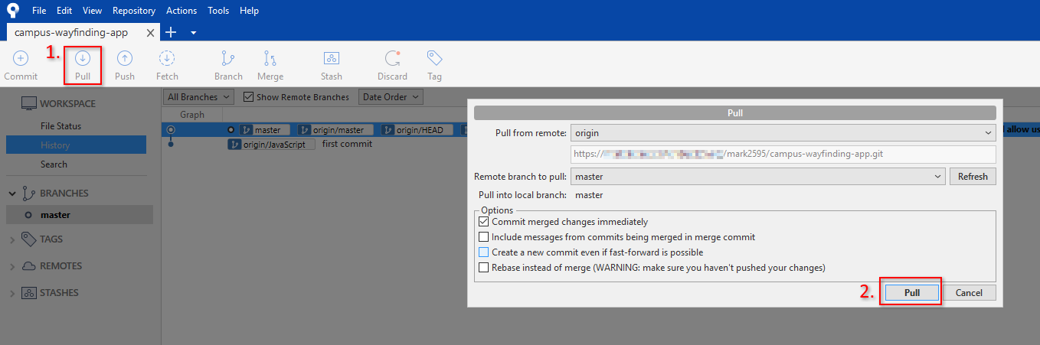

You are now setup to work on the code.

# Setting up the IDE in Windows

Download and install Visual Studio Code (<https://code.visualstudio.com/>)

Accept all defaults and start the application.

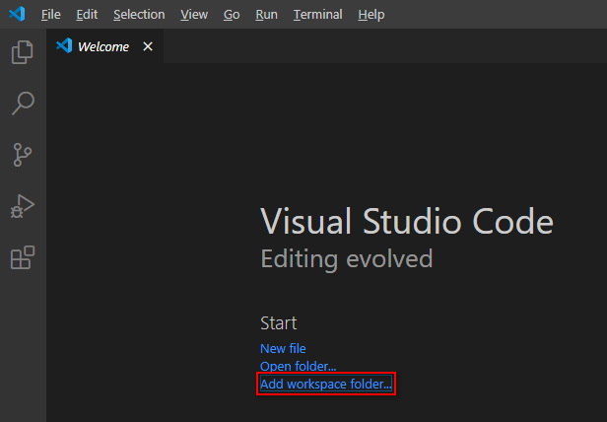

Once opened click ‘Add workspace folder’

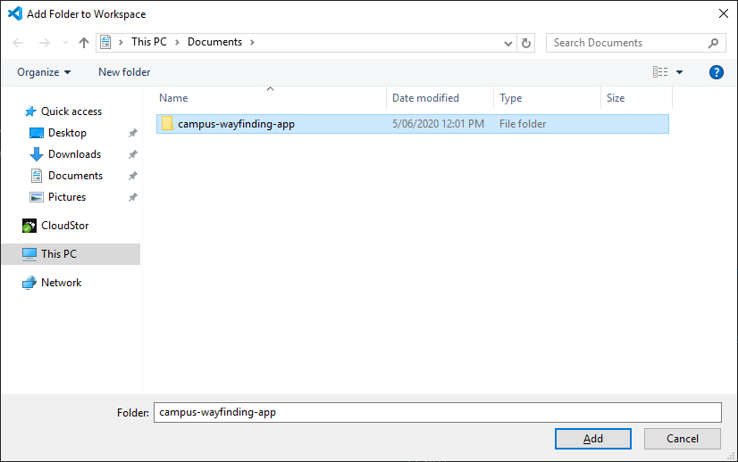

Select the ‘campus-wayfinding-app’ folder found under:

%userprofile%\Documents\campus-wayfinding-app

This will now give you a full view of all the project files, as shown below:

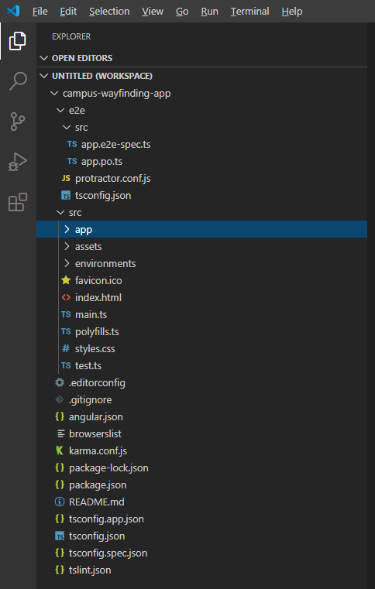

In the menu bar at the top of the screen select Terminal > New Terminal

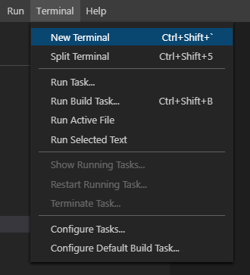

Type: node -v

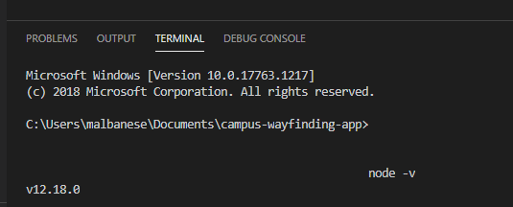

If you don’t receive a version number then you might need to install Node.js for Windows, (<https://nodejs.org/en/download/>).

If you do receive a version number, then run the following commands.

npm install -g @angular/cli

then

ng serve –open

if you get errors running ng serve –open, then try the following:

npm install --save-dev @angular-devkit/build-angular

once the package has complied, try running the following again:

ng serve –open

if successful, you will now have a webpage pop-up on the screen to load the app.

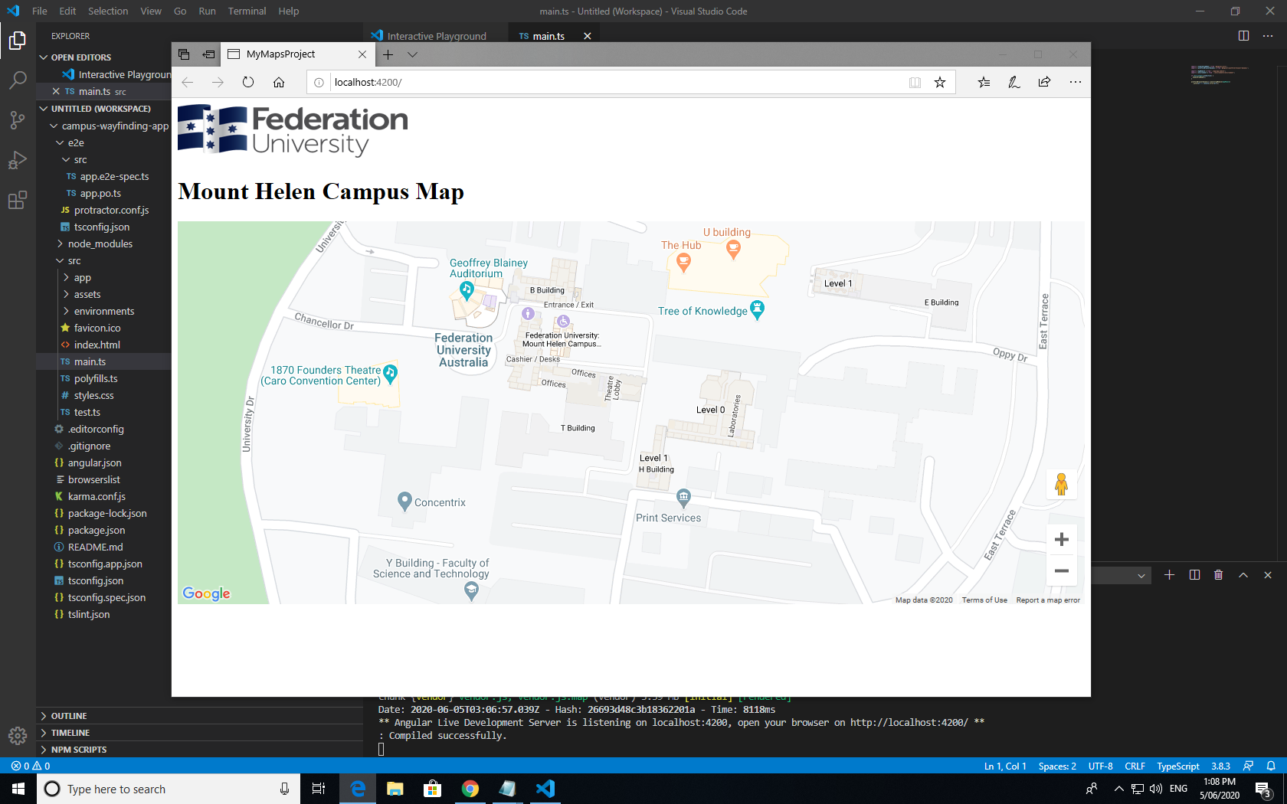

# Further readings

https://nodejs.org/en/,

<https://docs.npmjs.com/cli/install>